Super Vector Machine Regression:
Parameter – ‘linear’, without standardisation technique
R_score below:
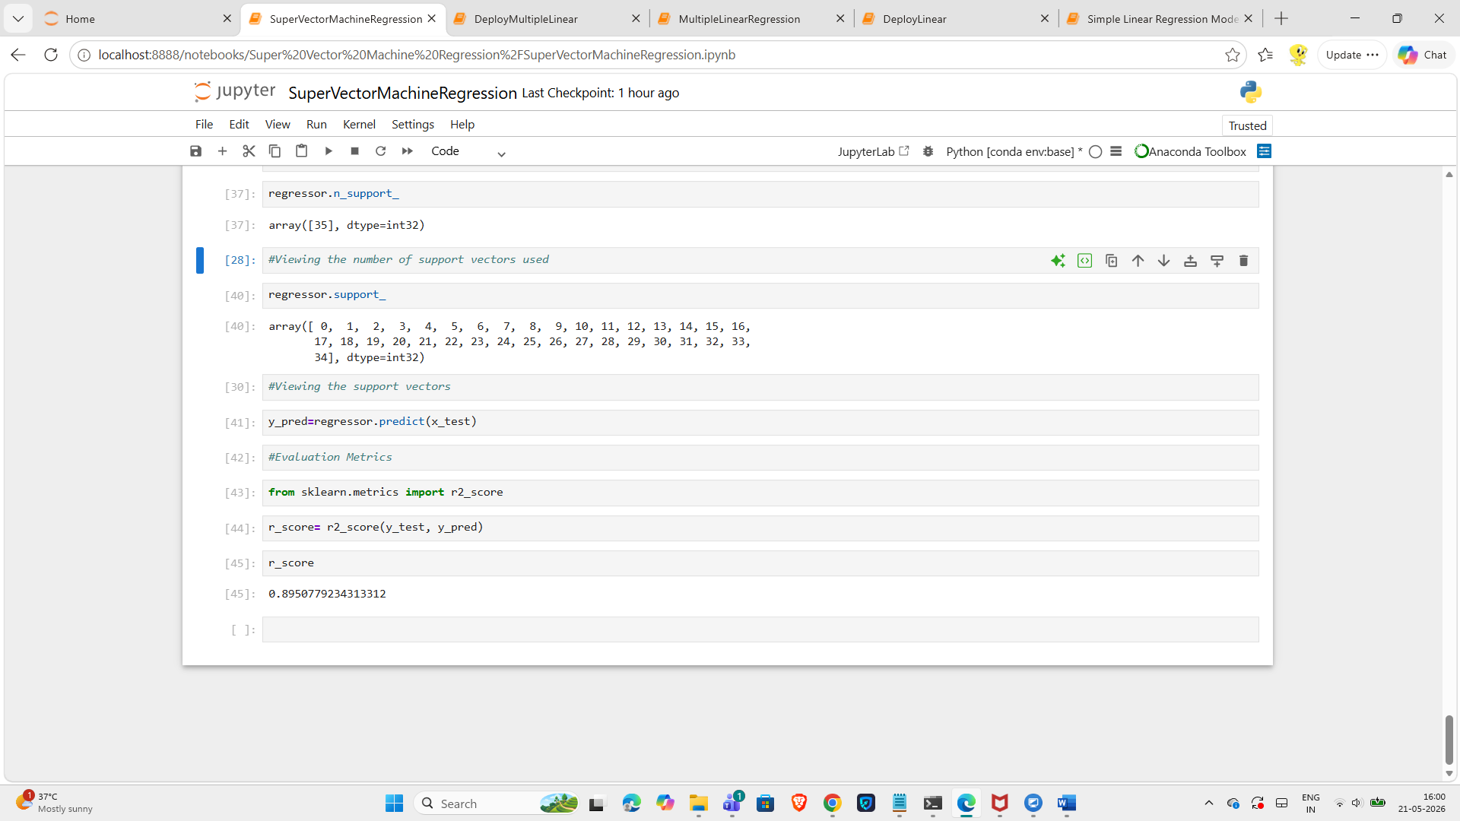

With Standardisation technique, kernel - linear
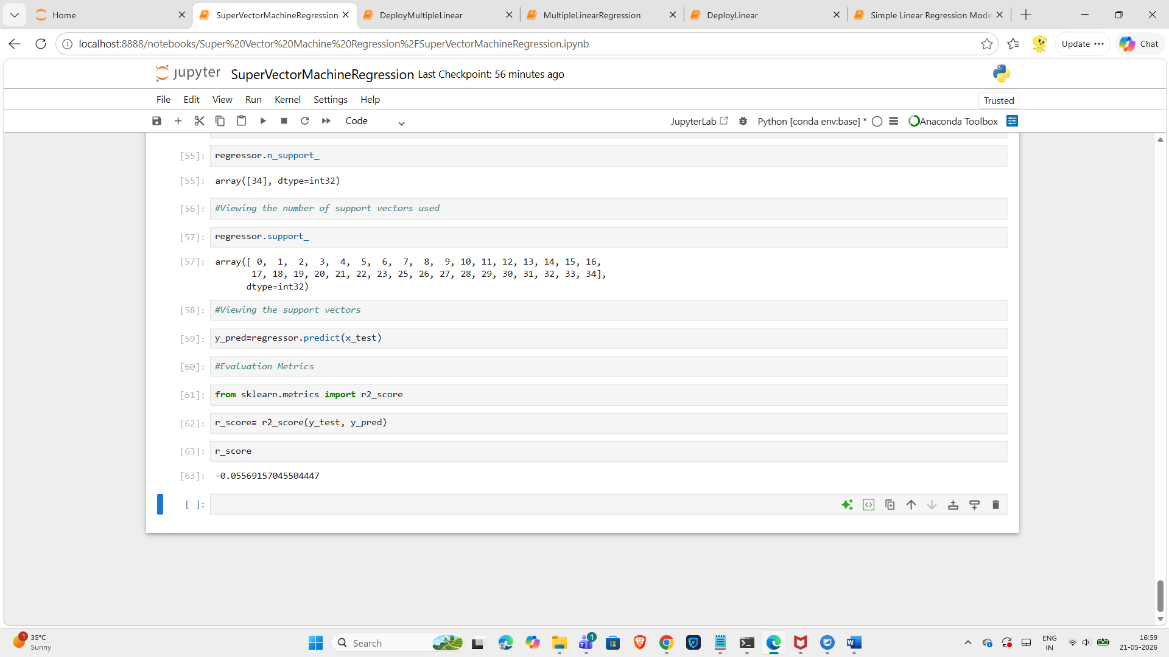

Super Vector Machine Regression:
Parameter – ‘rbf’, without standardisation technique
R_score below:
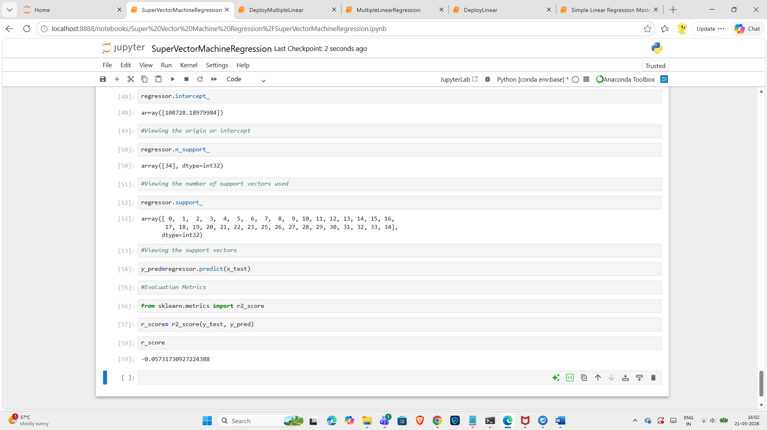
Standardisation technique used after training and test data split and before model creation steps below:
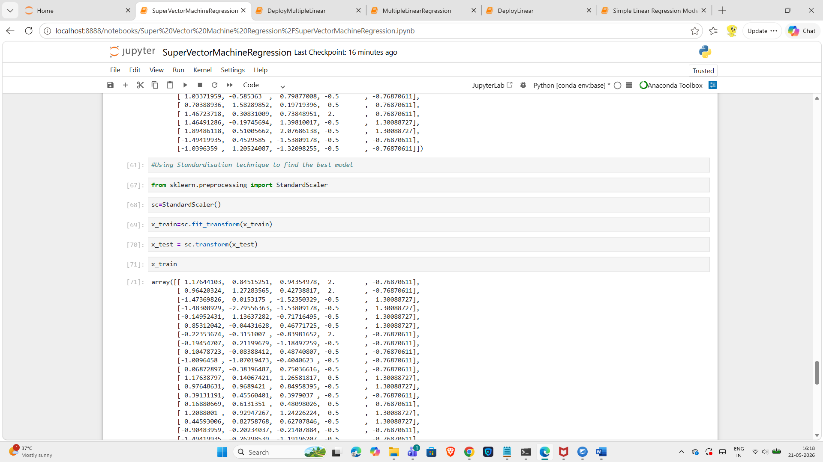

Super Vector Machine Regression
Kernel – ‘poly’
With standardisation technique
R_score below:
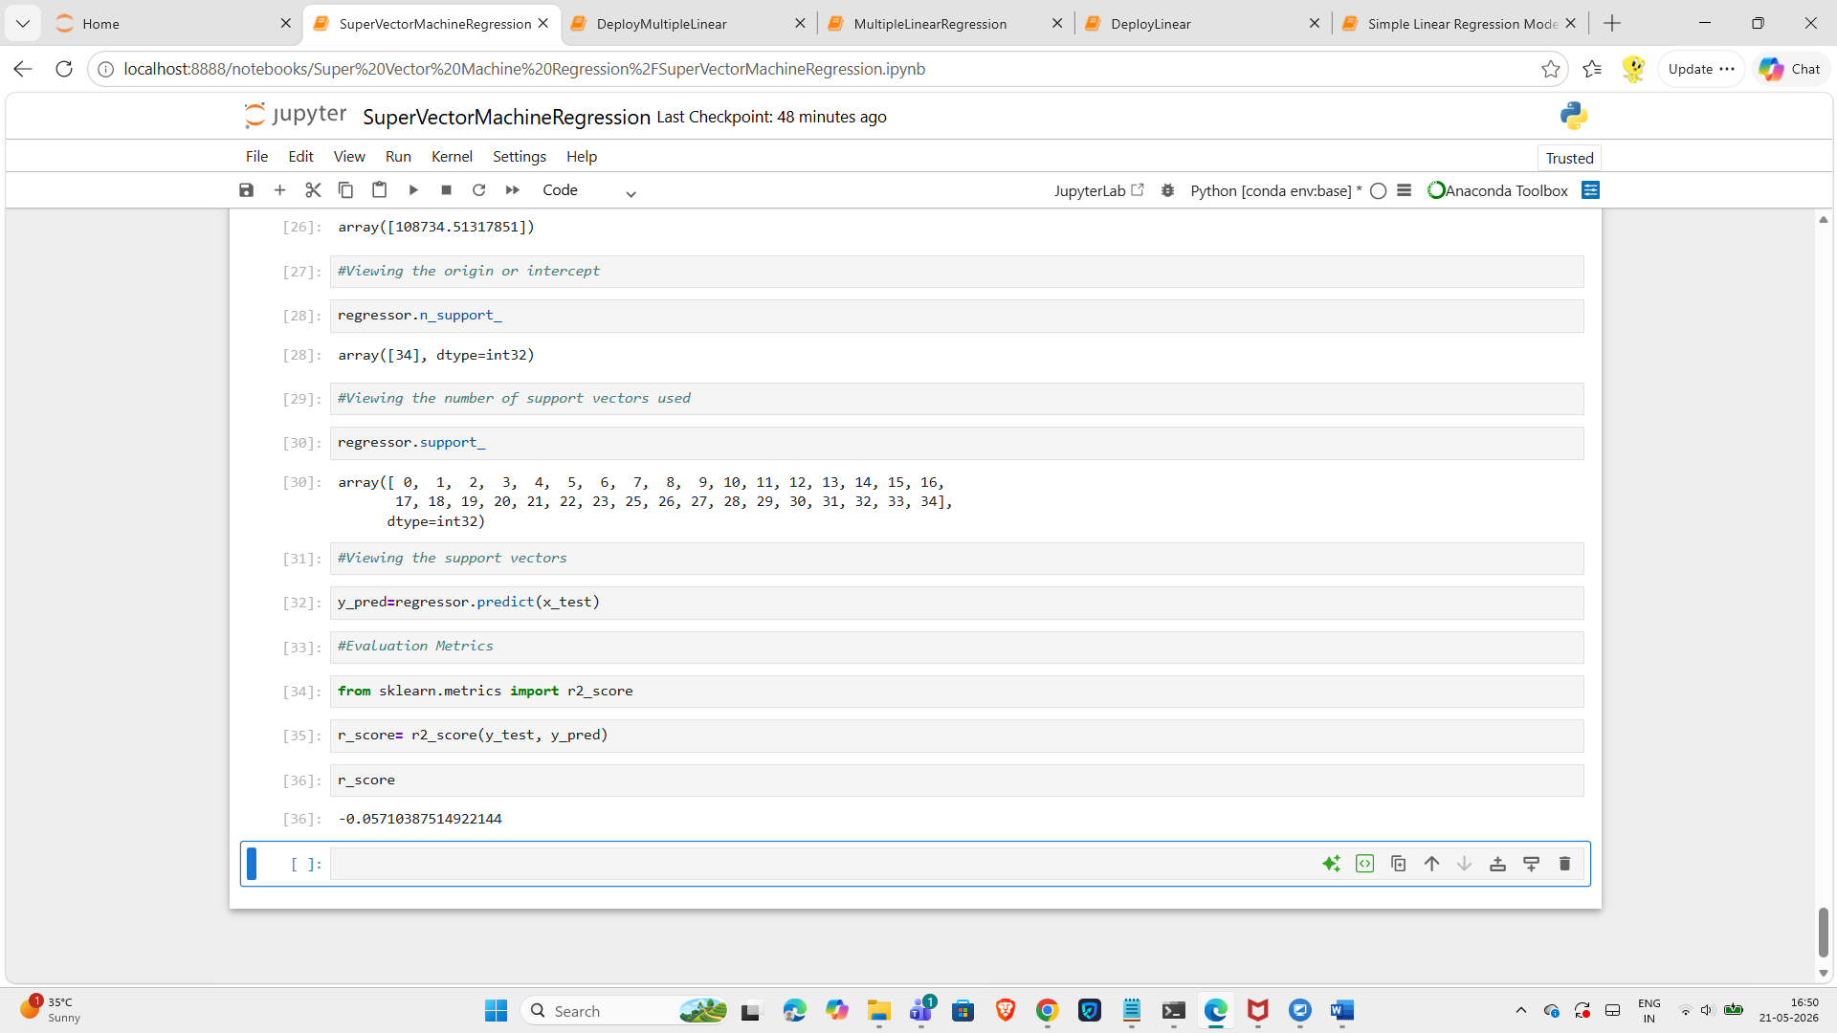

Super Vector Machine Regression:
Kernel – ‘sigmoid’
With Standardisation technique
R_score below:
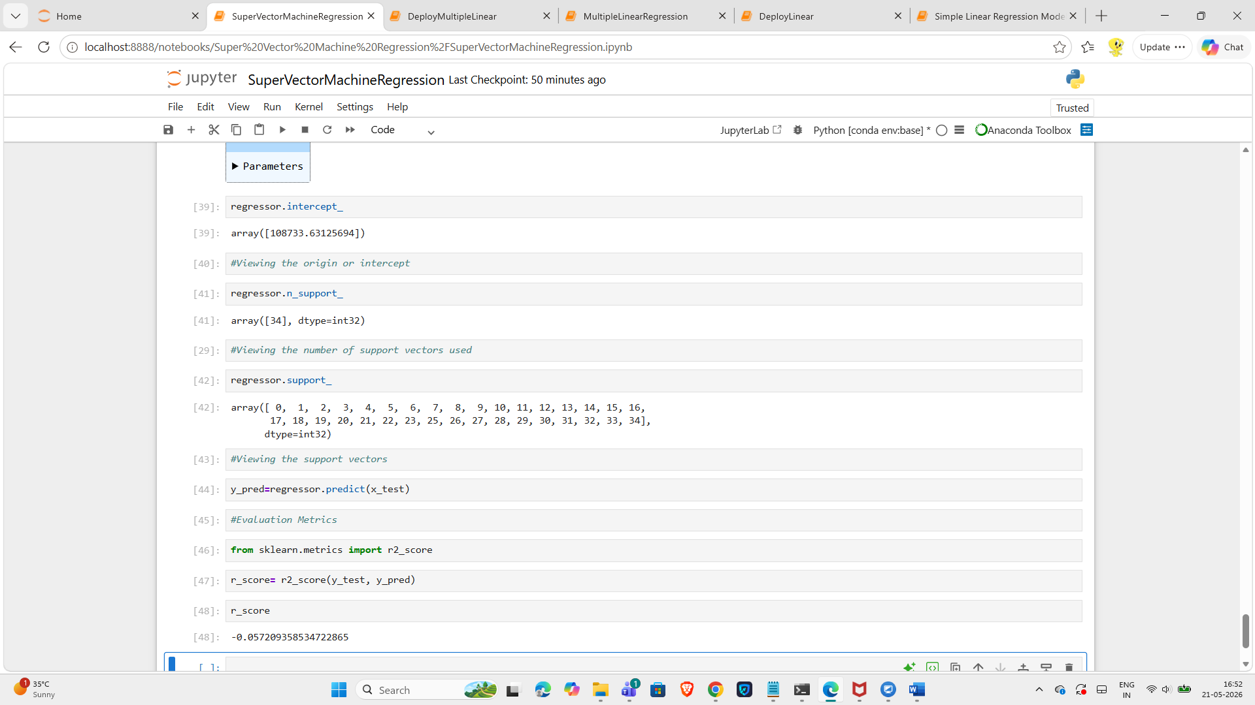

Super Vector Machine Regression:
Parameter – ‘rbf’
With Standardisation Technique
R_score below:
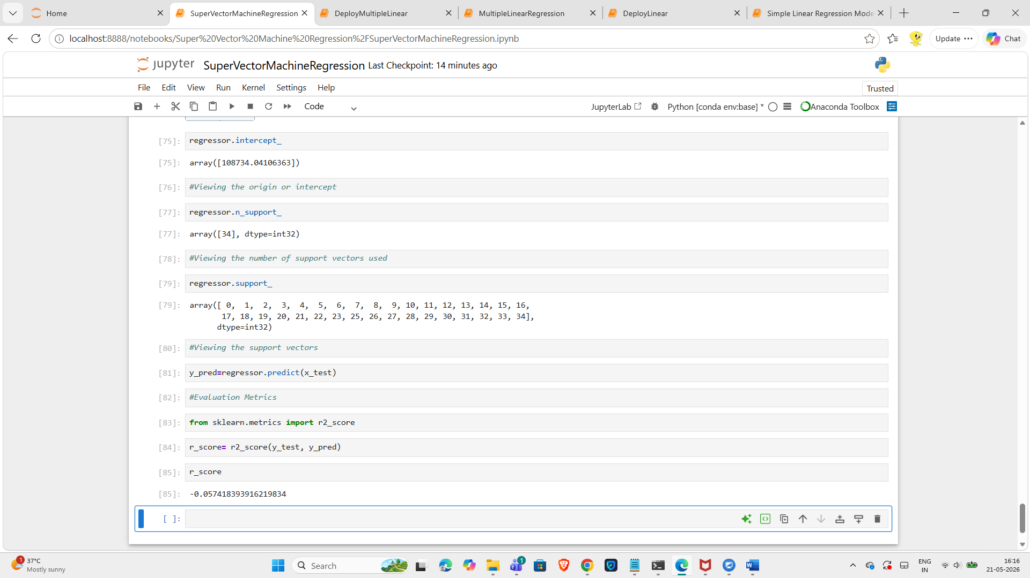

Super Vector Machine Regression:
Kernel – ‘precomputed’
With standardisation technique
When the code is run with ‘precomputed’, the following error message is thrown:
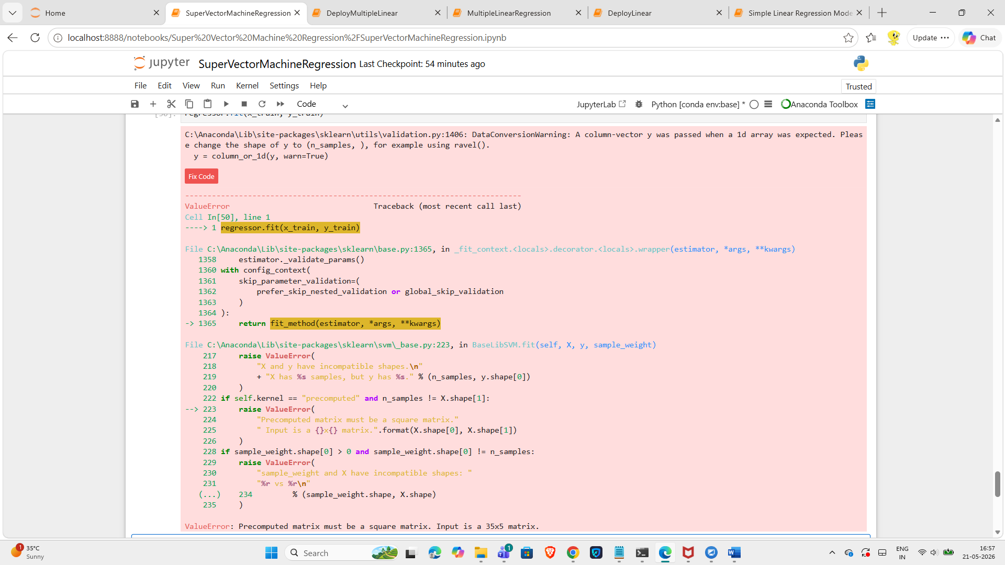

Precomputed will not work for this dataset.
Read this article:
https://scikit-learn.org/stable/modules/generated/sklearn.svm.SVR.html

